Table of Contents

Appendix A: Belt Selection 2

Appendix B: Gears Selection 10

Appendix C: Shaft Selection 16

Appendix D: Bearing Selection 21

Appendix E: Key Selection 25

Appendix F: Motor Selection 26

Appendix G: Shaft Calculations 27

Appendix H: 3D Models and Drawings 39

# Appendix A: Belt Selection



  

Appendix B: Gears Selection 

# Appendix C: Shaft Selection

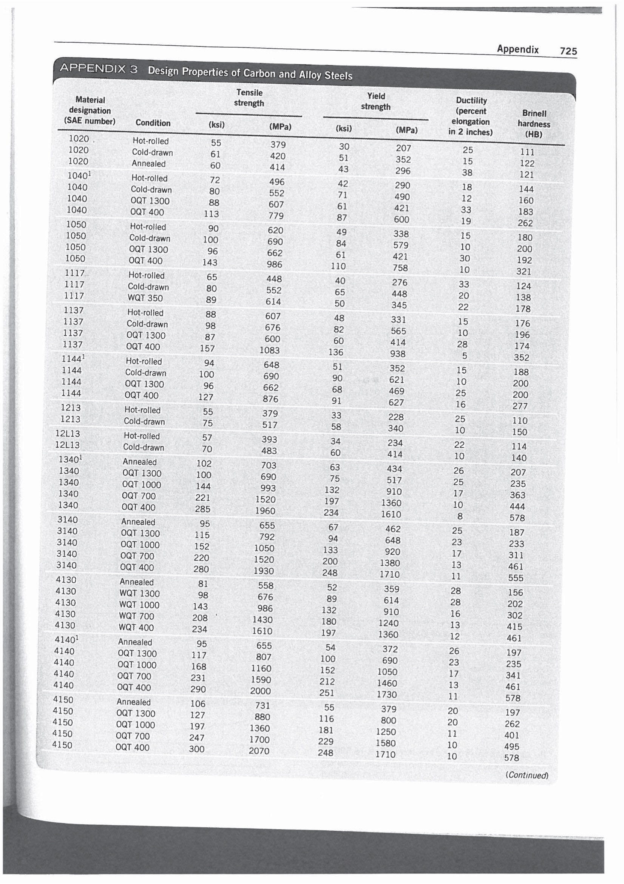 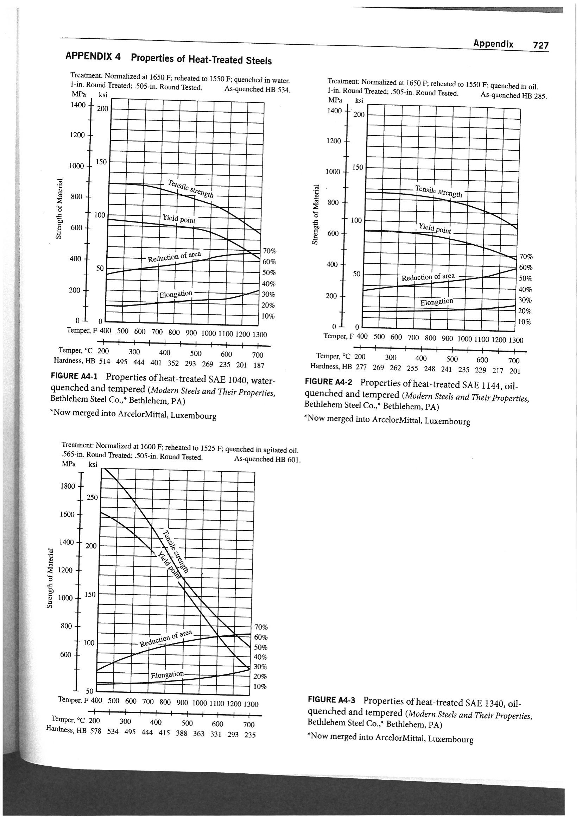 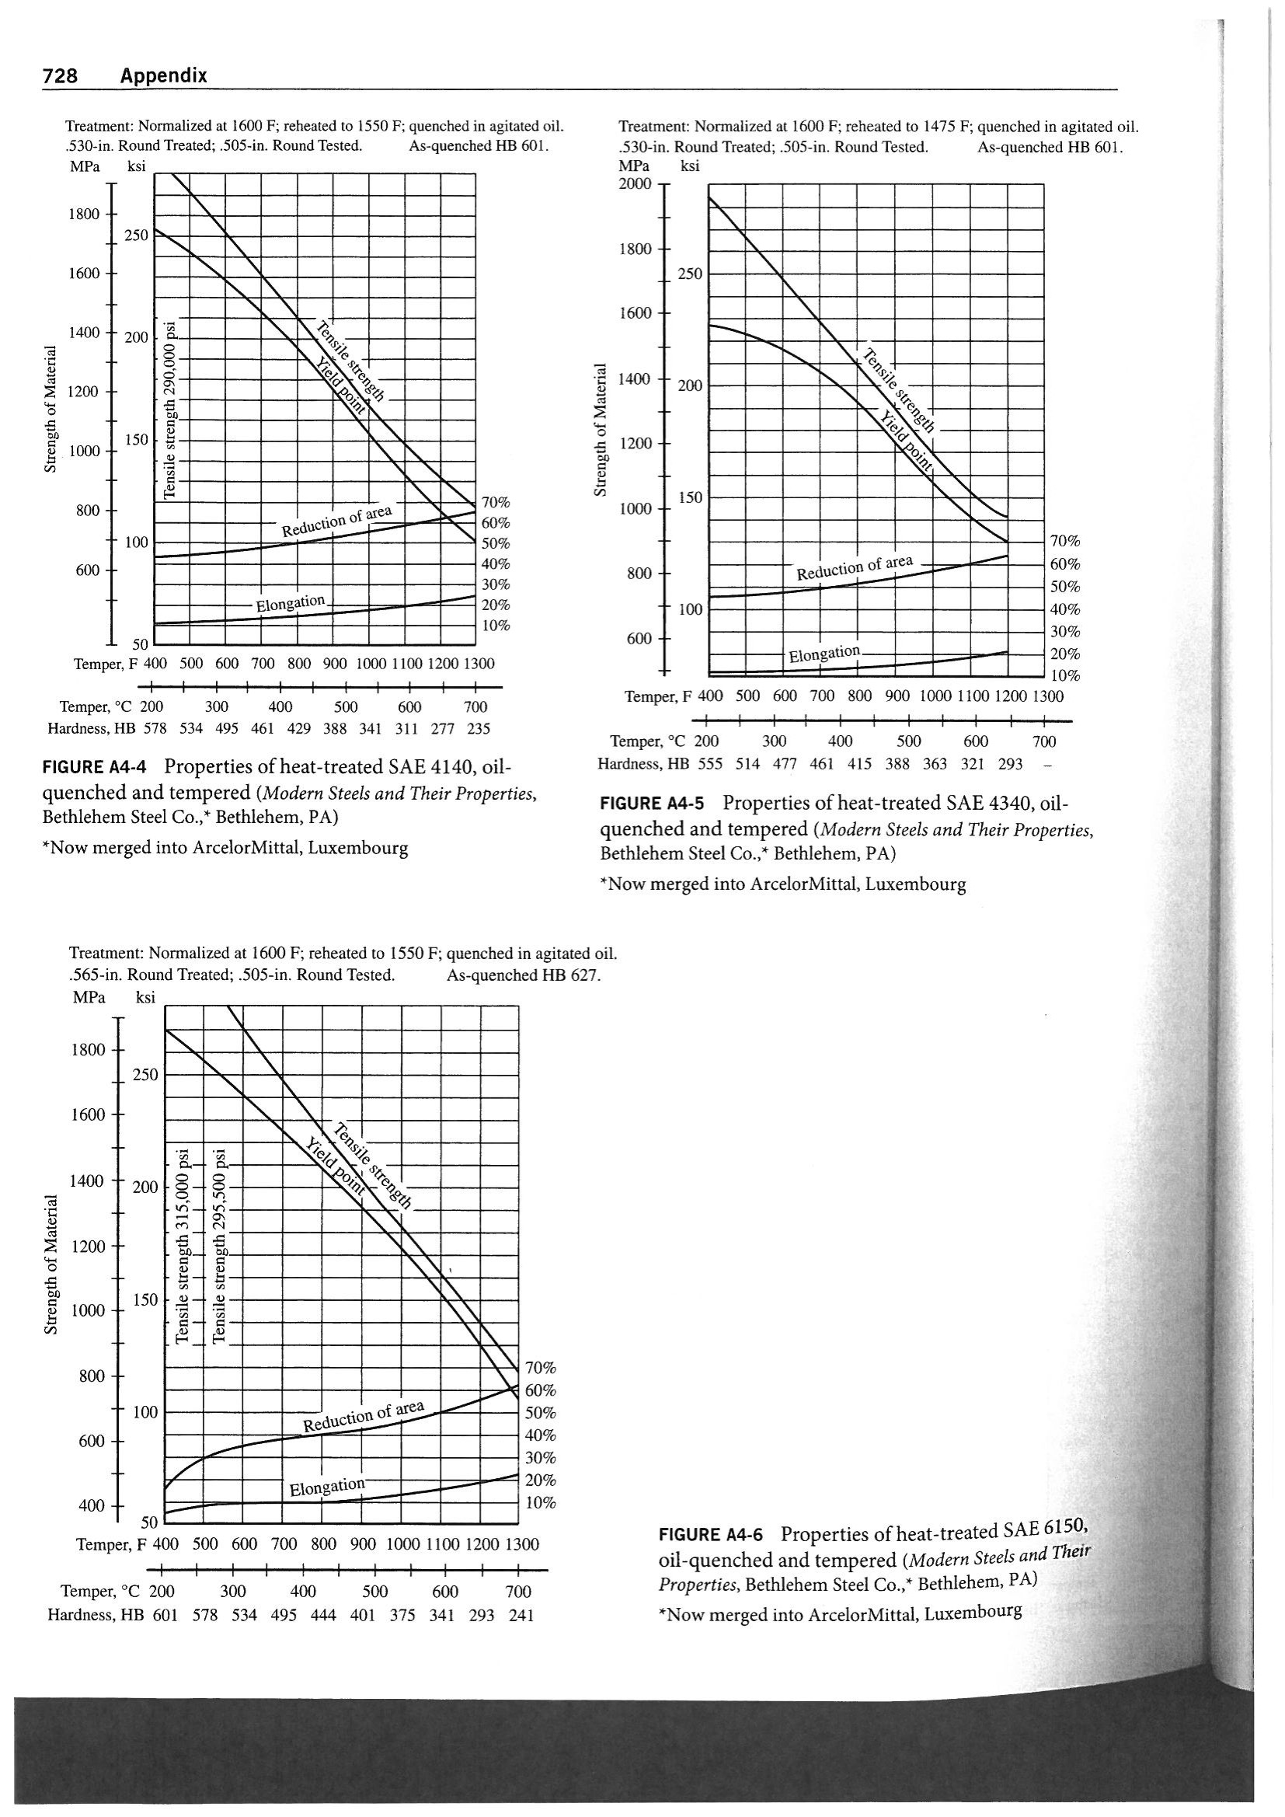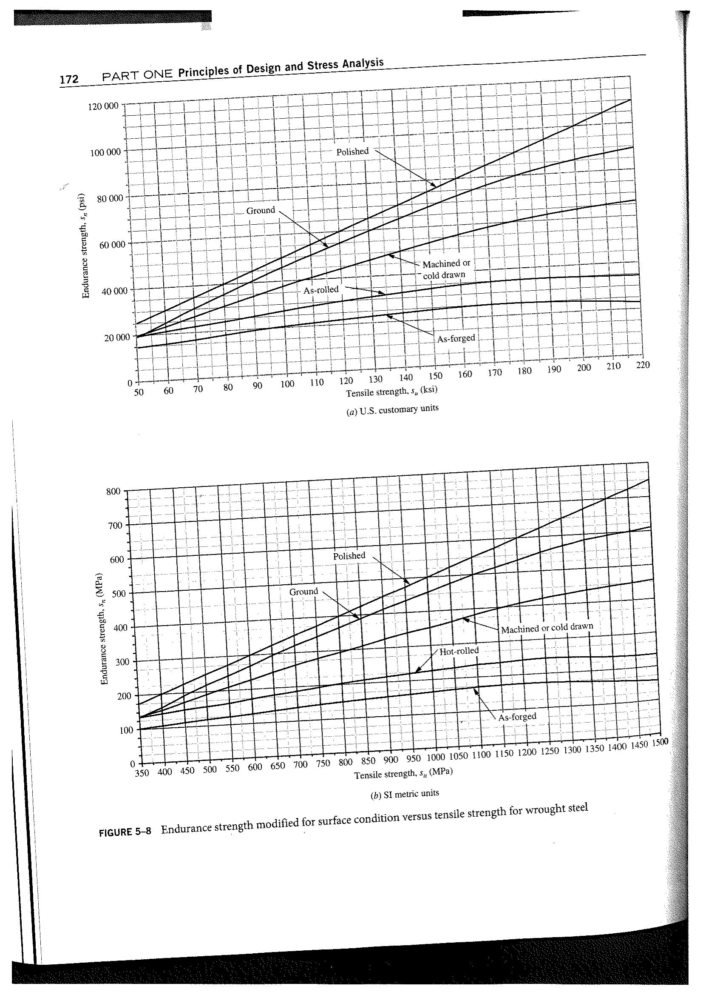

# Appendix D: Bearing Selection

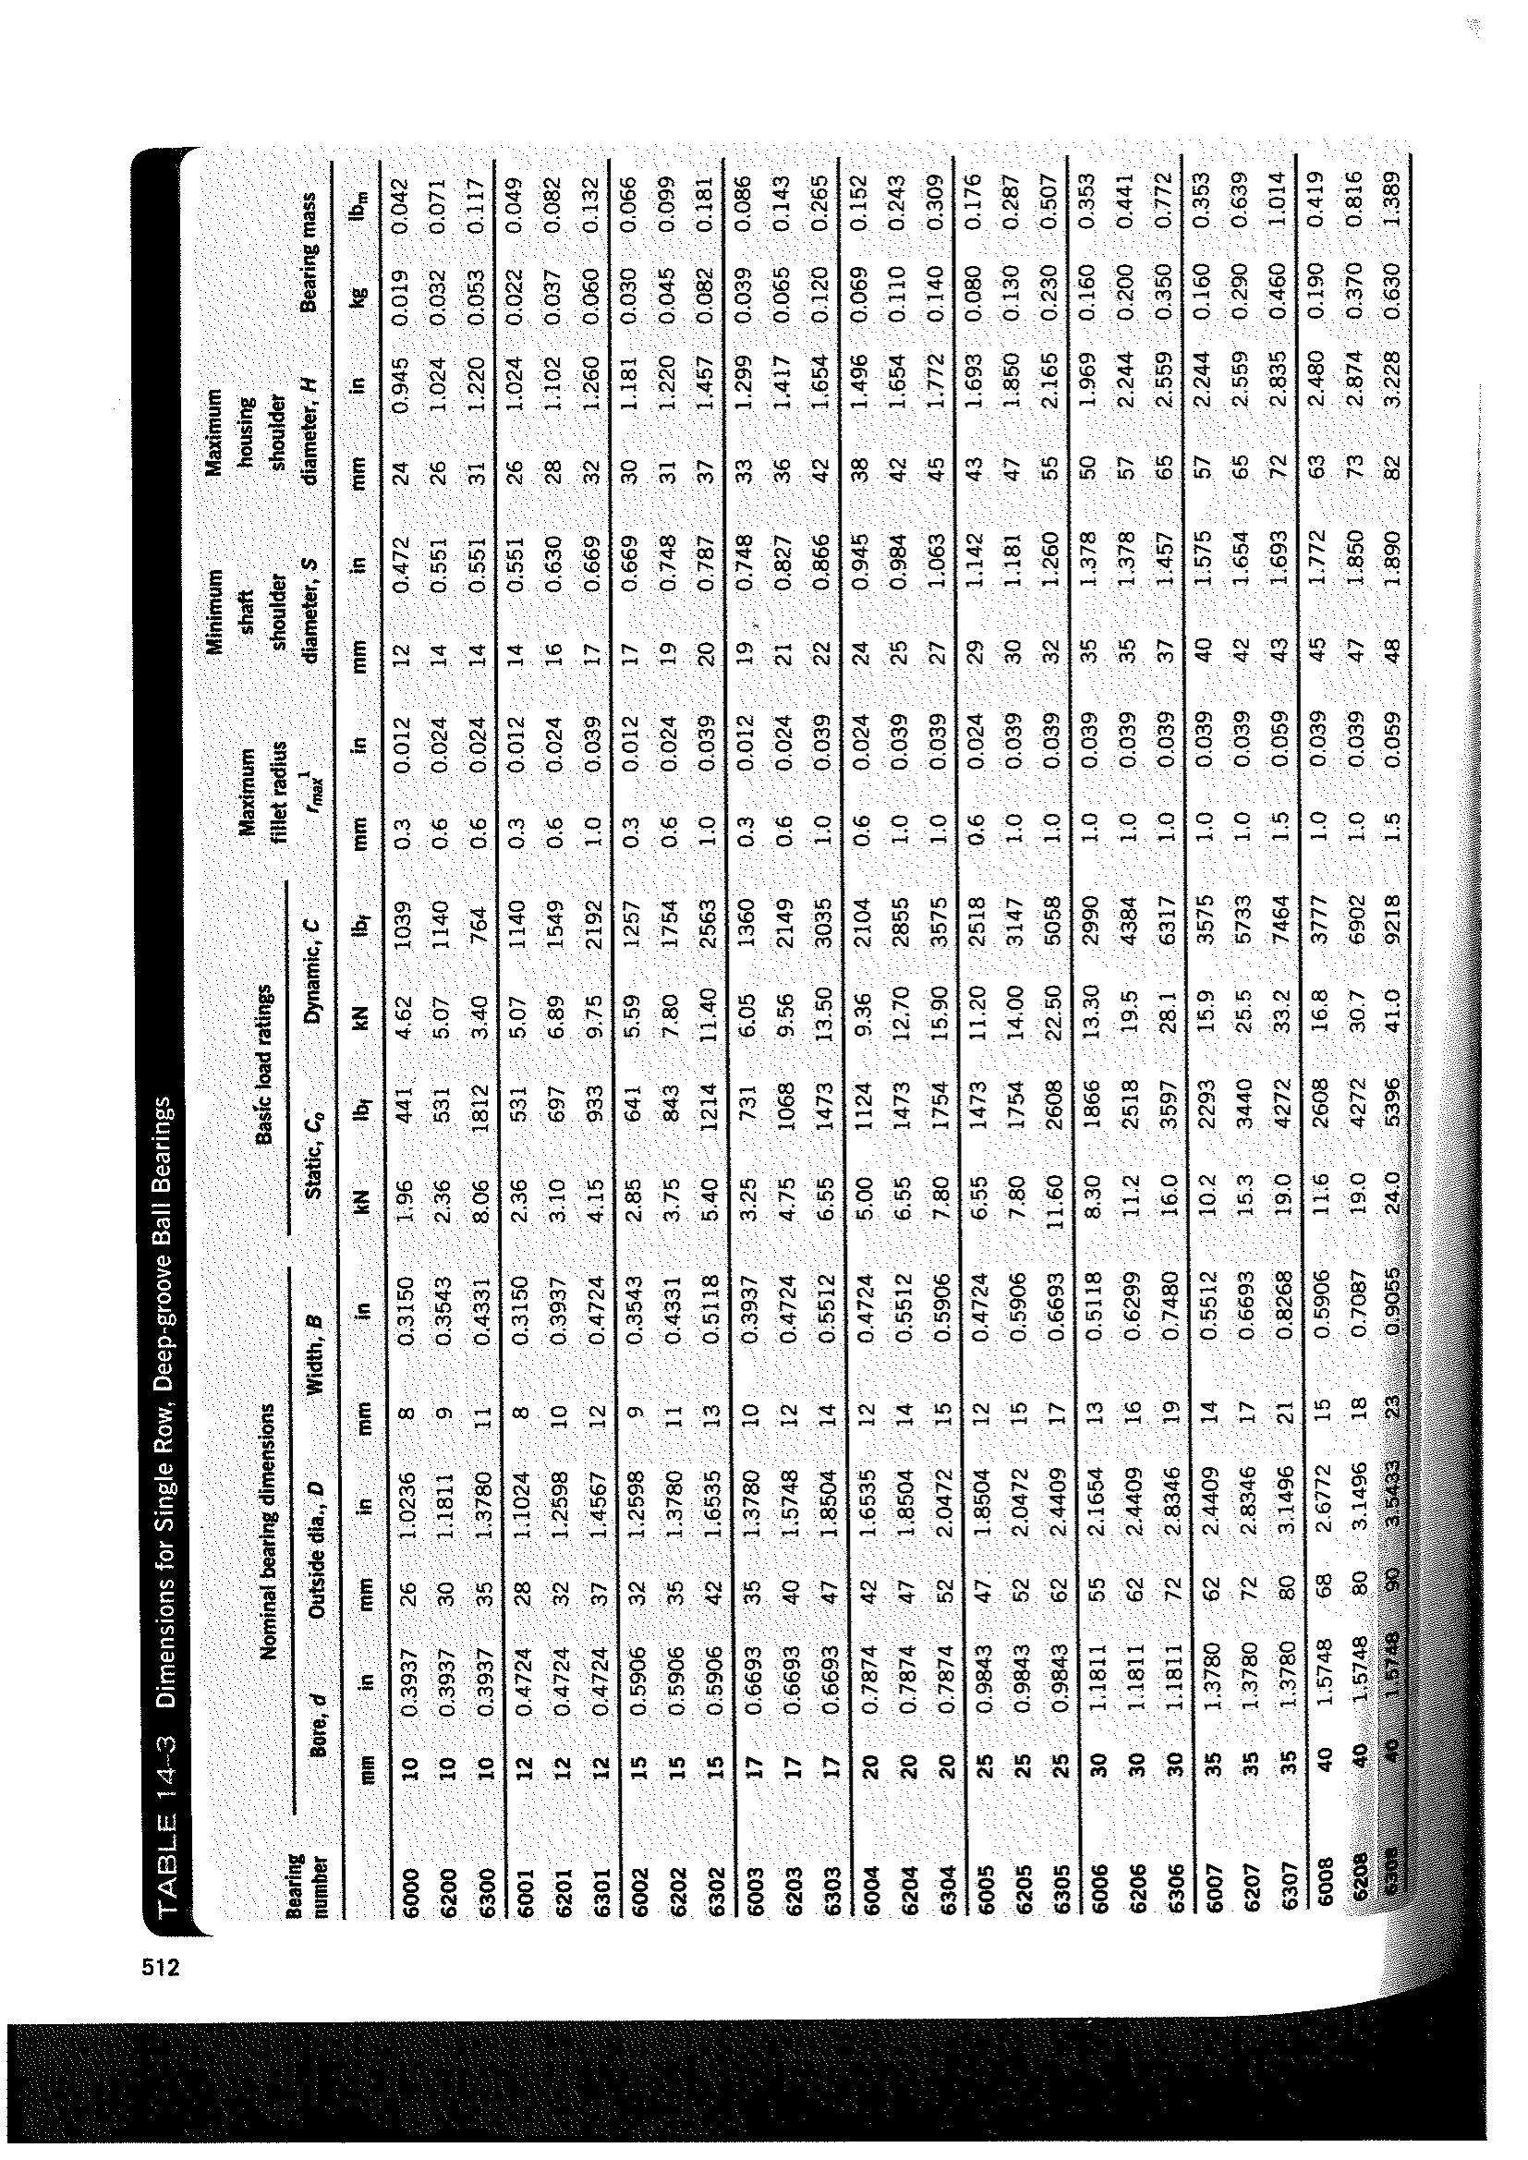 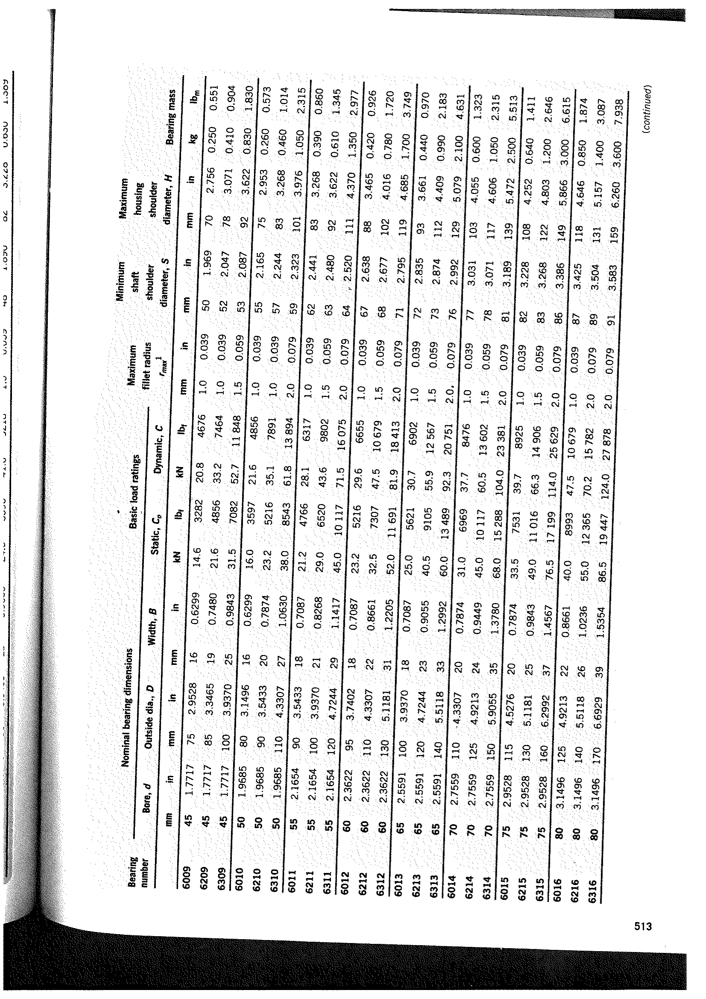 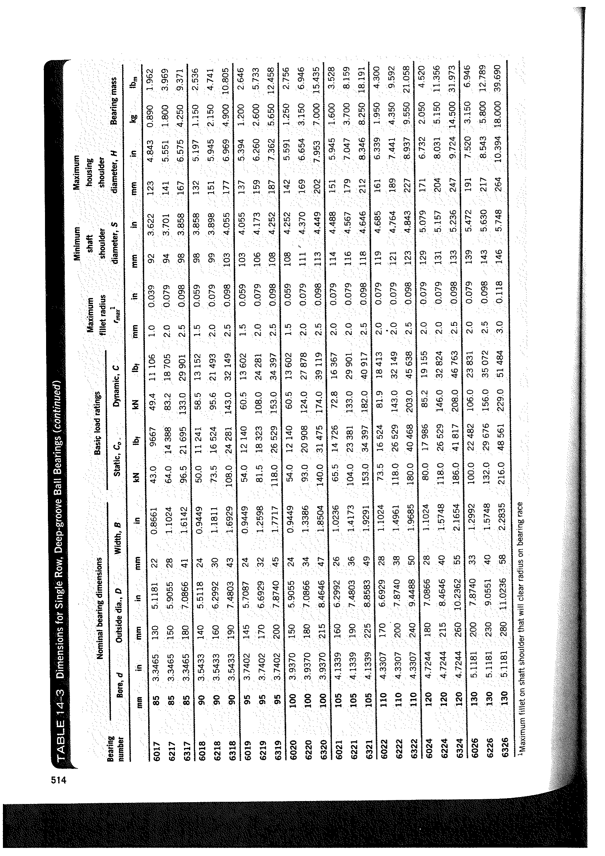

Appendix E: Key Selection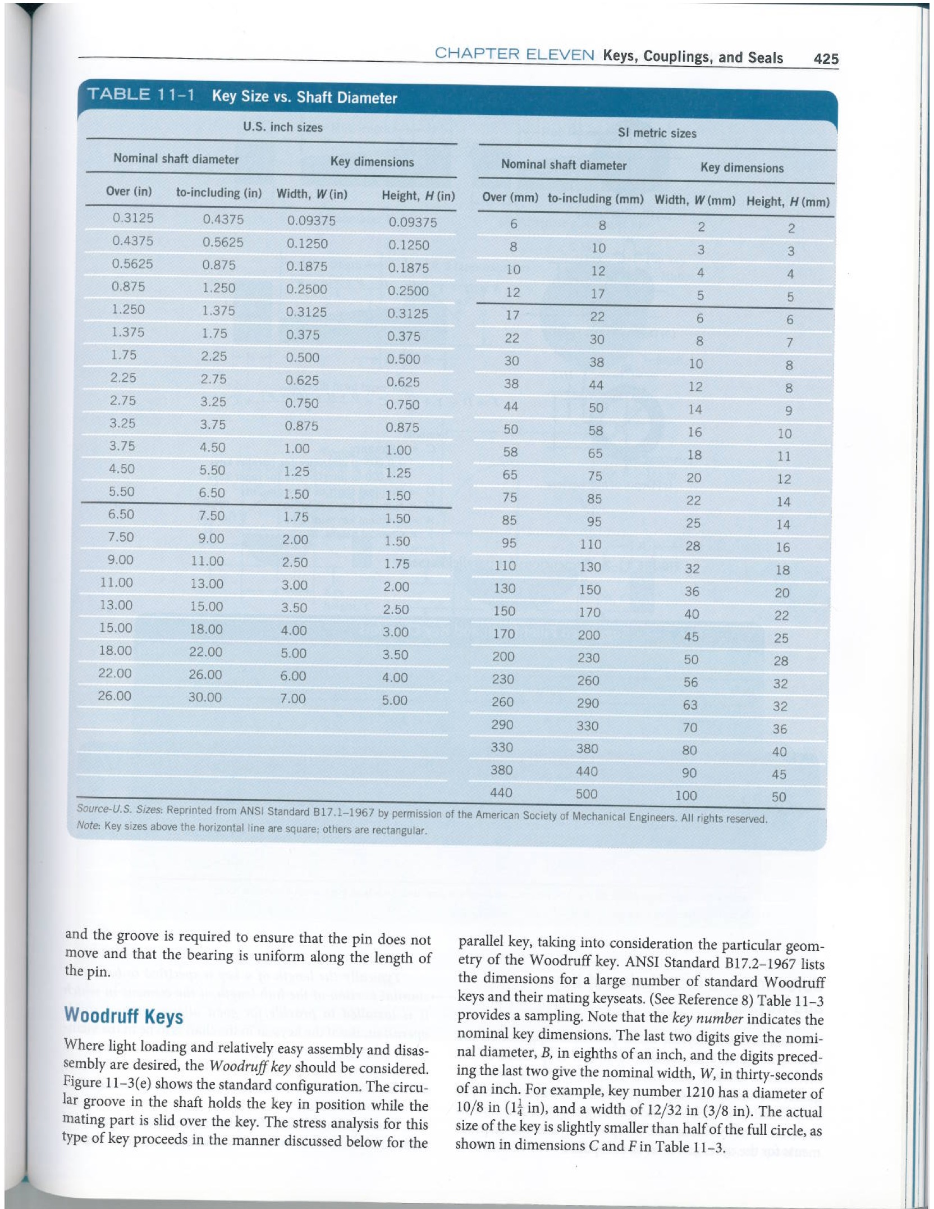

# Appendix F: Motor Selection

/Users/majiahao/Desktop/3001/TEC-Single-Phase-Cap-Start-Motor-Drawing.pdf

# Appendix G: Shaft Calculations

Assumptions: (1) Bearing and gears have negligible weight,

(2) Rollers are welded on the shafts.

Note: Negative gear forces indicate force going downward on the shear force diagram

**Shaft 1 Calculations**

Pulley B : $F_{a}=60.96N$

Gear 1: $W_{t1}=320N, W_{r1}=116.47N$

Step 1: Find Forces on Bearing D and C in y and z-axis

Z-Axis

Take clockwise as positive,

$ΣM_{BZ}=0,$

$$W_{t1}*0.04+F_{Az}*0.02=0$$

$$F_{Az}=-640N$$

$$ΣF_{y}=0,$$

$$F_{Bz}=960N$$

Y-Axis

Take clockwise as positive,

Step 2: Load, Shear Force, Bending Moment diagram

X-Z Plane X-Y Plane

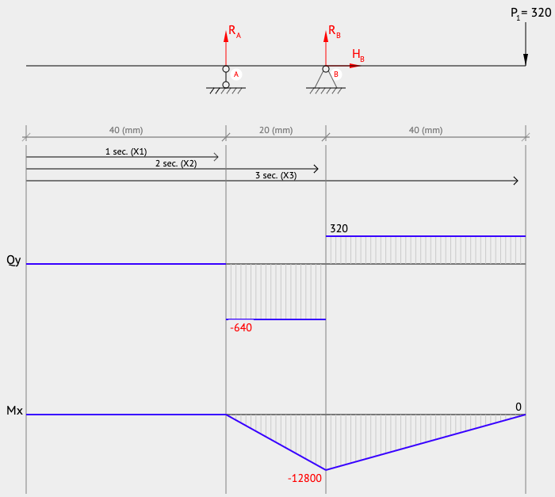 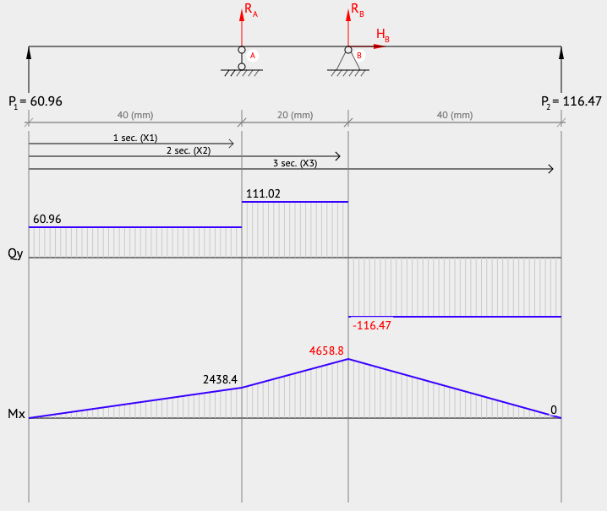

Step 3: Resultant moment and Torque

,

Tbearings = T1 = Ta = 3.8368 Nm

**Step 4: determine shaft diameter**

Material: SAE 1137 alloy steel

Condition: Cold-drawn

Tensile strength, Su: 676MPa, Yield Strength, Sy: 565MPa and Endurance strength, Sn=280MPa.

Assume = 0.82, =0.91(99% reliability)

$$S_{n}^{'}={S_{n}*C}_{s}*C_{r}$$

To find diameter,

$$D={(\frac{32N}{π}\sqrt{{\left(\frac{K_{fb}M}{S_{n}^{'}}\right)}^{2}+\frac{3}{4}{\left(\frac{T}{S_{y}}\right)}^{2}})}^{1/3}$$

|  |  |  |  |  |  |  |  |
| --- | --- | --- | --- | --- | --- | --- | --- |
| Location | Component | Kfb | M  (Nm) | T(Nm) | Min Diameter(mm) | Updated $C_{s}$ | Updated Diameter (mm) |
| Left of Pulley | Retaining ring | 3.0 | 0 | 3.84 | 5.64 | 1.0 | 5.64 |
| Center of Pulley | Profile Key | 2.0 | 0 | 3.84 | 5.64 | 1.0 | 5.64 |
| Right of Pulley | Well-rounded | 1.5 | 0 | 3.84 | 5.64 | 1.0 | 5.64 |
| Left Bearing A | Well-rounded | 1.5 | 2.44 | 3.84 | 8.27 | 0.99 | 7.81 |
| Center bearing A | Press fit | 1.0 | 2.44 | 3.84 | 7.37 | 1.0 | 7.0 |
| Right bearing A | Sharp fillet | 2.5 | 2.44 | 3.84 | 9.69 | 0.97 | 9.18 |
| Left of Bearing B | Sharp fillet | 2.5 | 13.69 | 3.84 | 17.11 | 0.91 | 16.5 |
| Center of Bearing B | Press fit | 1.0 | 13.69 | 3.84 | 12.62 | 0.95 | 12.04 |
| Right of Bearing B | Well-rounded | 1.5 | 13.69 | 3.84 | 14.44 | 0.93 | 13.84 |
| Left of Gear 1 | Well-rounded | 1.5 | 0 | 3.84 | 5.64 | 1.0 | 5.64 |
| Center of Gear 1 | Profile key | 2.0 | 0 | 3.84 | 5.64 | 1.0 | 5.64 |
| Right of Gear 1 | Retaining ring | 3.0 | 0 | 3.84 | 5.64 | 1.0 | 5.64 |

**Shaft 2 Calculations**

Gear 3: $W_{t3}=575N, W_{r3}=209.3N$,

Gear 2: $W_{t2}=-383.3N, W_{r2}=139.52N$

Step 1: Find Forces on Bearing D and C in y and z-axis

Z-Axis

Take clockwise as positive,

$ΣM_{DZ}=0,$

$$W_{t3}*0.02-F_{Cz}*0.08-W_{t2}*0.06=0$$

$$F_{Cz}=862.45N$$

$$ΣF_{Z}=0,$$

$F_{Dz}=-1054.15N$

Y-Axis

Take clockwise as positive,

Step 2: Load, Shear Force, Bending Moment diagram

X-Z Plane X-Y Plane

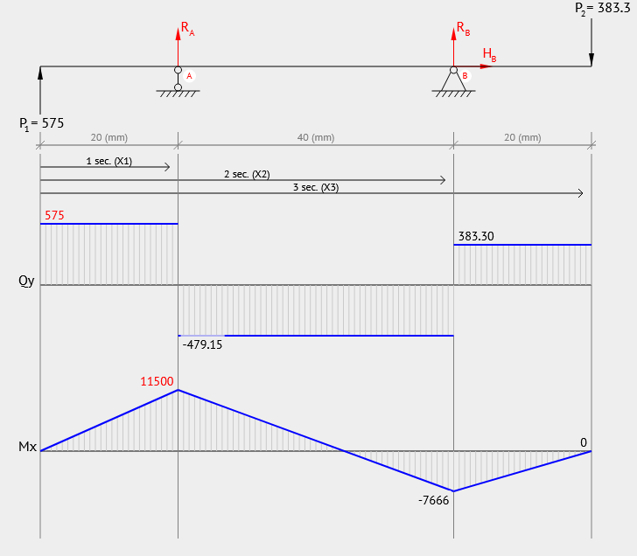 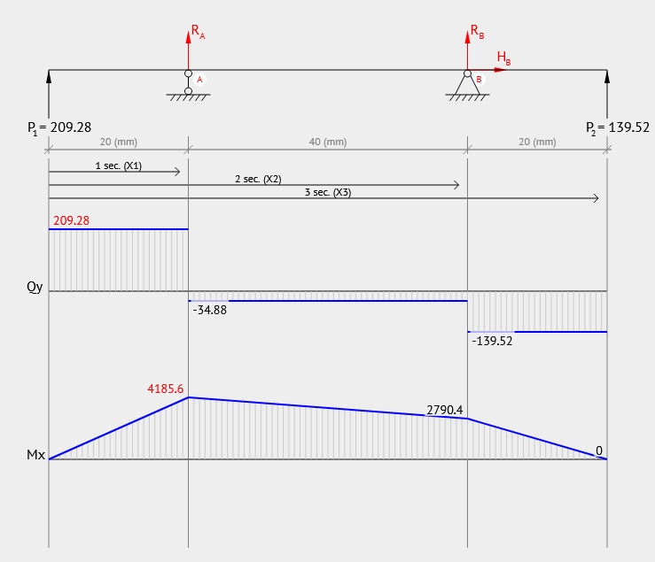

Step 3: Resultant moment and Torque

,

Tbearings = T2 = T3 = 10.35 Nm

Step 4: determine shaft diameter

SAE number 1340 OQT 700 alloy steel (Appendix C) is chosen as the shaft material for shaft 2 and 3 because it has higher strength, direct hardening and is suitable for higher stress applications.

Material: SAE 1340 alloy steel

Condition: OQT 700

Tensile strength, Su: 1520MPa, Yield Strength, Sy: 1360MPa and Endurance strength,

Sn= 450MPa.

Assume = 0.82, =0.91(99% reliability).

$$S_{n}^{'}={S_{n}*C}_{s}*C_{r}$$

To find diameter,

$$D={(\frac{32N}{π}\sqrt{{\left(\frac{K_{fb}M}{S_{n}^{'}}\right)}^{2}+\frac{3}{4}{\left(\frac{T}{S_{y}}\right)}^{2}})}^{1/3}$$

|  |  |  |  |  |  |  |  |
| --- | --- | --- | --- | --- | --- | --- | --- |
| Location | Component | Kfb | M  (Nm) | T(Nm) | Min Diameter(mm) | Updated $C_{s}$ | Updated Diameter (mm) |
| Left of Gear 2 | Retaining ring | 3.0 | 0 | 10.35 | 5.86 | 1.0 | 5.86 |
| Center of Gear 2 | Profile Key | 2.0 | 0 | 10.35 | 5.86 | 1.0 | 5.86 |
| Right of Gear 2 | Well-rounded | 1.5 | 0 | 10.35 | 5.86 | 1.0 | 5.86 |
| Left Bearing C | Well-rounded | 1.5 | 8.16 | 10.35 | 10.04 | 0.97 | 9.87 |
| Center bearing C | Press fit | 1.0 | 8.16 | 10.35 | 9.16 | 0.98 | 8.68 |
| Right bearing C | Sharp fillet | 2.5 | 8.16 | 10.35 | 12.31 | 0.95 | 11.73 |
| Left of Bearing D | Sharp fillet | 2.5 | 12.24 | 10.35 | 14.08 | 0.93 | 13.50 |
| Center of Bearing D | Press fit | 1.0 | 12.24 | 10.35 | 10.42 | 0.97 | 9.87 |
| Right of Bearing D | Well-rounded | 1.5 | 12.24 | 10.35 | 11.89 | 0.95 | 11.33 |
| Left of Gear 3 | Well-rounded | 1.5 | 0 | 10.35 | 5.86 | 1.0 | 5.86 |
| Center of Gear 3 | Profile key | 2.0 | 0 | 10.35 | 5.86 | 1.0 | 5.86 |
| Right of Gear 3 | Retaining ring | 3.0 | 0 | 10.35 | 5.86 | 1.0 | 5.86 |

**Shaft 3 Calculations**

Gear 5: $W_{t5}=-970.42N, W_{r5}=-353.2N$,

Gear 4: $W_{t4}=575.06N, W_{r4}=-209.3N$

Step 1: Find Forces on Bearing D and C in y and z-axis

Z-Axis

Take clockwise as positive,

$ΣM_{FZ}=0,$

$$W_{t5}*0.02-F_{Ez}*0.08-W_{t4}*0.06=0$$

$$F_{Ez}=-1347.80 N$$

$$ΣF_{Z}=0,$$

$F_{Fz}=1743.16N$

Y-Axis

Take clockwise as positive,

Step 2: Load, Shear Force, Bending Moment diagram

X-Z Plane X-Y Plane

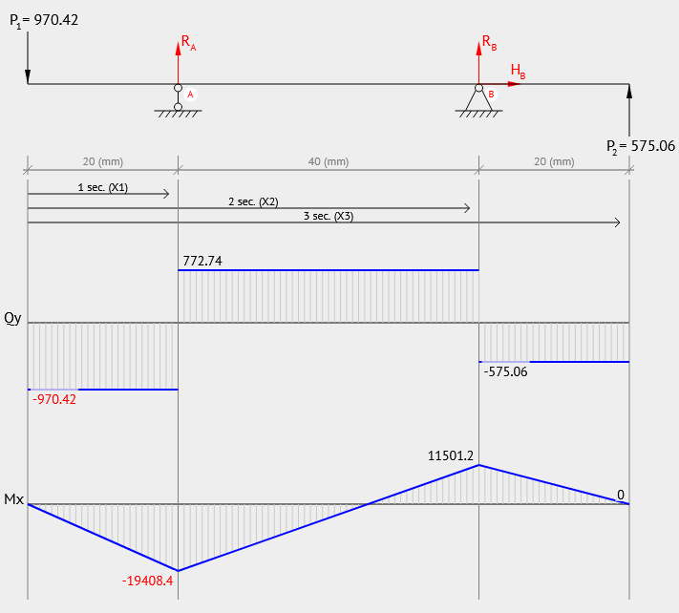 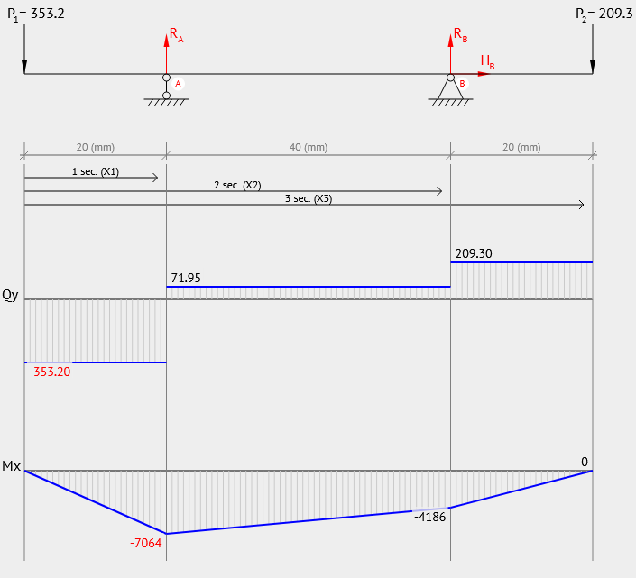

Step 3: Resultant moment and Torque

,

Tbearings = T4 = T5 = 23.29 Nm

Step 4: determine shaft diameter

SAE number 1340 OQT 700 alloy steel (Appendix C) is chosen as the shaft material for shaft 2 and 3 because it has higher strength, direct hardening and is suitable for higher stress applications.

Material: SAE 1340 alloy steel

Condition: OQT 700

Tensile strength, Su: 1520MPa, Yield Strength, Sy: 1360MPa and Endurance strength,

Sn= 450MPa.

Assume = 0.82, =0.91(99% reliability).

$$S_{n}^{'}={S_{n}*C}_{s}*C_{r}$$

To find diameter,

$$D={(\frac{32N}{π}\sqrt{{\left(\frac{K_{fb}M}{S_{n}^{'}}\right)}^{2}+\frac{3}{4}{\left(\frac{T}{S_{y}}\right)}^{2}})}^{1/3}$$

|  |  |  |  |  |  |  |  |
| --- | --- | --- | --- | --- | --- | --- | --- |
| Location | Component | Kfb | M  (Nm) | T(Nm) | Min Diameter(mm) | Updated $C_{s}$ | Updated Diameter (mm) |
| Left of Gear 4 | Retaining ring | 3.0 | 0 | 23.29 | 7.68 | 1.0 | 7.68 |
| Center of Gear 4 | Profile Key | 2.0 | 0 | 23.29 | 7.68 | 1.0 | 7.68 |
| Right of Gear 4 | Well-rounded | 1.5 | 0 | 23.29 | 7.68 | 1.0 | 7.68 |
| Left Bearing E | Well-rounded | 1.5 | 12.24 | 23.29 | 12.01 | 0.95 | 11.48 |
| Center bearing E | Press fit | 1.0 | 12.24 | 23.29 | 10.63 | 0.96 | 10.18 |
| Right bearing E | Sharp fillet | 2.5 | 12.24 | 23.29 | 14.13 | 0.93 | 13.57 |
| Left of Bearing F | Sharp fillet | 2.5 | 20.65 | 23.29 | 16.77 | 0.92 | 16.15 |
| Center of Bearing F | Press fit | 1.0 | 20.65 | 23.29 | 12.46 | 0.95 | 11.90 |
| Right of Bearing F | Well-rounded | 1.5 | 20.65 | 23.29 | 14.19 | 0.93 | 13.62 |
| Left of Gear 5 | Well-rounded | 1.5 | 0 | 23.29 | 7.68 | 1.0 | 7.68 |
| Center of Gear 5 | Profile key | 2.0 | 0 | 23.29 | 7.68 | 1.0 | 7.68 |
| Right of Gear 5 | Retaining ring | 3.0 | 0 | 23.29 | 7.68 | 1.0 | 7.68 |

**Force analysis of shaft 5**

Gear 8: $W_{t8}=397.27, W_{r8}=154.6N$,

Roller: $W_{tR}=437N, W_{NR}=874N$.

**Step 1: Find Forces on Bearing G and H in y and z-axis**

Z-Axis

Take clockwise as positive,

$ΣM_{IZ}=0,$

$$W_{t8}*0.025+W_{tR}*0.175-F_{JZ}*0.375=0$$

$$F_{JZ}=246.88N$$

$$ΣF_{Z}=0,$$

$$F_{IZ}=-207.15N$$

Y-Axis

Take clockwise as positive,

$ΣM_{Iy}=0,$

$$W_{r8}*0.025-W_{NR}*0.175-F_{Jy}*0.375=0$$

$$F_{Jy}=-425.96N$$

$$ΣF_{y}=0,$$

$$F_{Iy}= -602.64N$$

Step 2: Load, Shear Force, Bending Moment diagram

X-Z Plane X-Y Plane

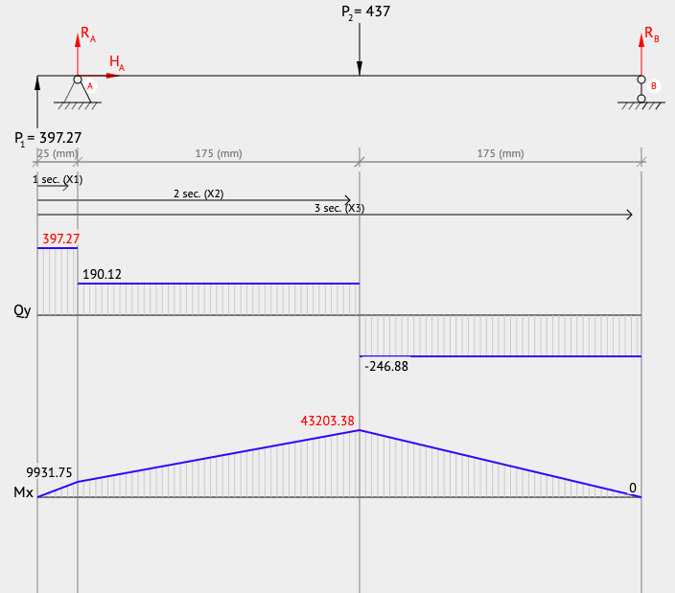 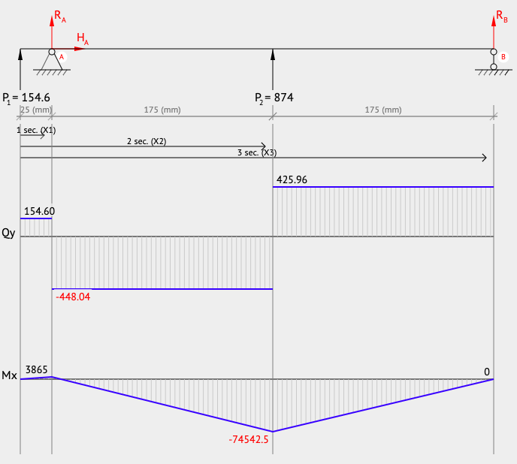

Step 3: Resultant moment and Torque

,

Tbearings = T4 = T5 = 21.85 Nm

**Step 4: determine shaft diameter**

Material: SAE 1137 alloy steel

Condition: Cold-drawn

Tensile strength, Su: 676MPa, Yield Strength, Sy: 565MPa and Endurance strength, Sn= 280MPa.

Assume = 0.82, =0.91(99% reliability).

$$S_{n}^{'}={S_{n}*C}_{s}*C_{r}$$

To find diameter,

$$D={(\frac{32N}{π}\sqrt{{\left(\frac{K_{fb}M}{S_{n}^{'}}\right)}^{2}+\frac{3}{4}{\left(\frac{T}{S_{y}}\right)}^{2}})}^{1/3}$$

|  |  |  |  |  |  |  |  |
| --- | --- | --- | --- | --- | --- | --- | --- |
| Location | Component | Kfb | M  (Nm) | T(Nm) | Min Diameter(mm) | Updated $C_{s}$ | Updated Diameter (mm) |
| Left of Gear 8 | Retaining ring | 3.0 | 0 | 21.85 | 10.08 | 0.97 | 10.08 |
| Center of Gear 8 | Profile Key | 2.0 | 0 | 21.85 | 10.08 | 0.97 | 10.08 |
| Right of Gear 8 | Well-rounded | 1.5 | 0 | 21.85 | 10.08 | 0.97 | 10.08 |
| Left Bearing I | Well-rounded | 1.5 | 10.66 | 21.85 | 13.67 | 0.94 | 13.17 |
| Center bearing I | Press fit | 1.0 | 10.66 | 21.85 | 12.31 | 0.95 | 11.92 |
| Right bearing I | Sharp fillet | 2.5 | 10.66 | 21.85 | 15.91 | 0.92 | 15.35 |
| Left of Roller | Welded | 1.0 | 86.15 | 21.85 | 23.30 | 0.88 | 22.72 |
| Center of Roller | Welded | 1.0 | 86.15 | 21.85 | 23.30 | 0.88 | 22.72 |
| Right of Roller | Welded | 1.0 | 86.15 | 21.85 | 23.30 | 0.88 | 22.72 |
| Left of Bearing J | Sharp fillet | 2.5 | 0 | 21.85 | 10.08 | 0.97 | 10.08 |
| Center of Bearing J | Press fit | 1.0 | 0 | 21.85 | 10.08 | 0.97 | 10.08 |
| Right of Bearing J | Well-rounded | 1.5 | 0 | 21.85 | 10.08 | 0.97 | 10.08 |

# Appendix H: 3D Models and Drawings

**3D Model**: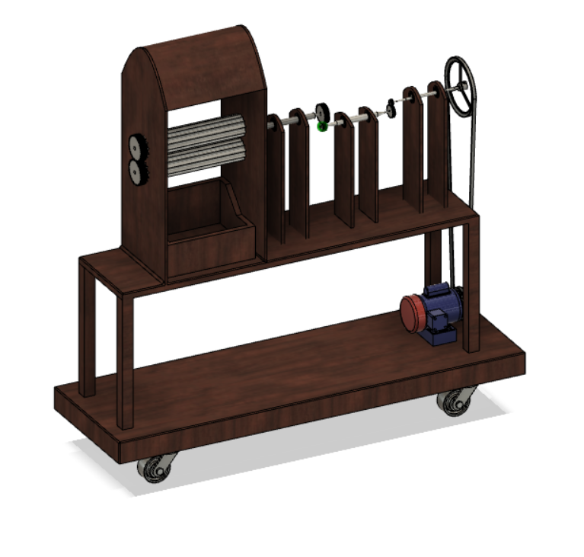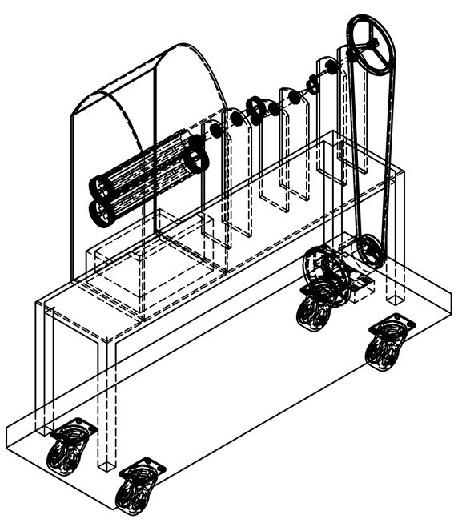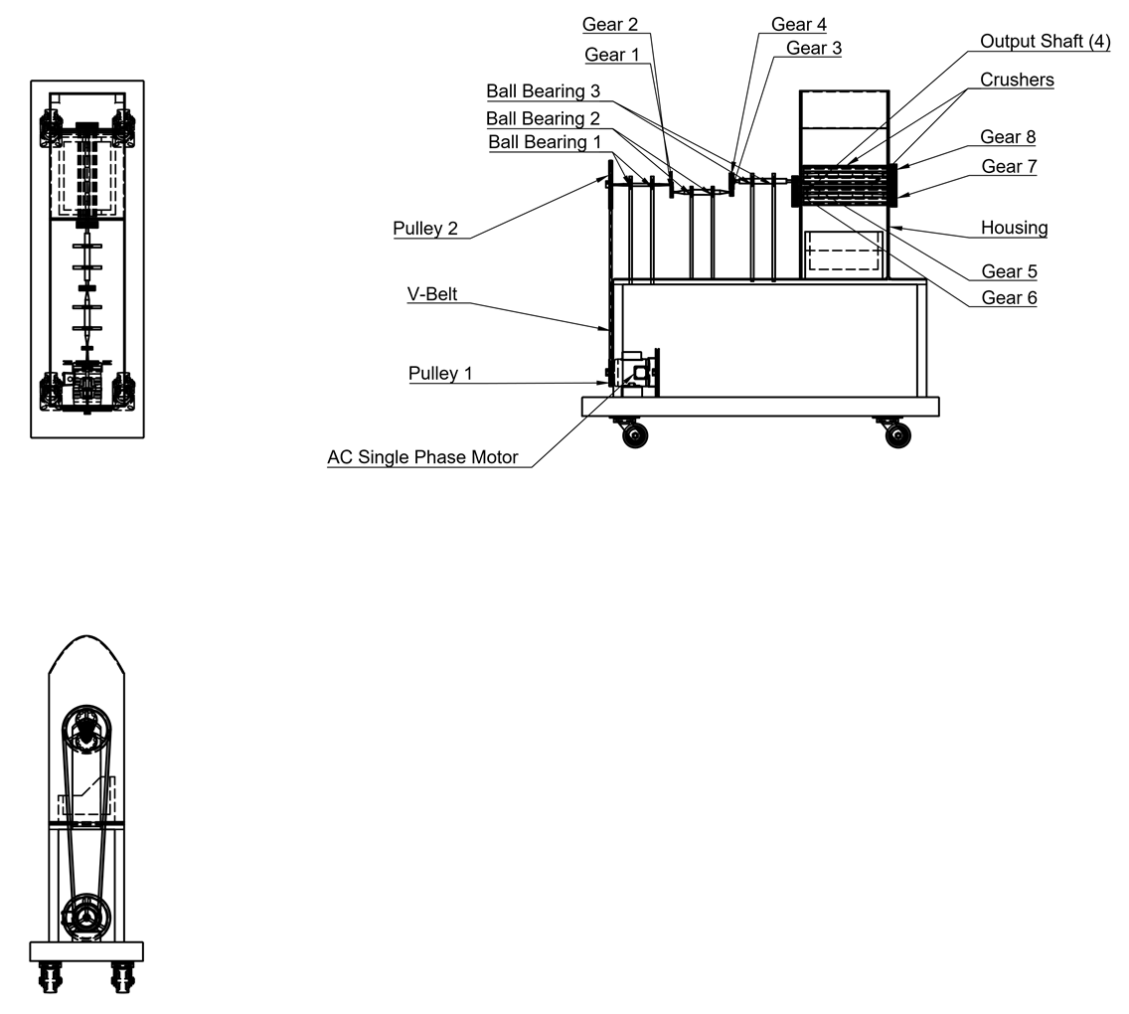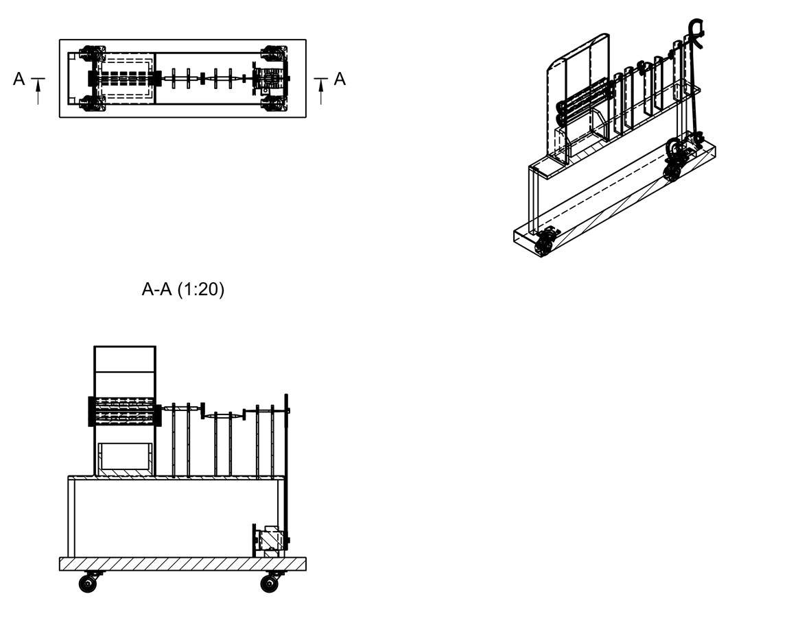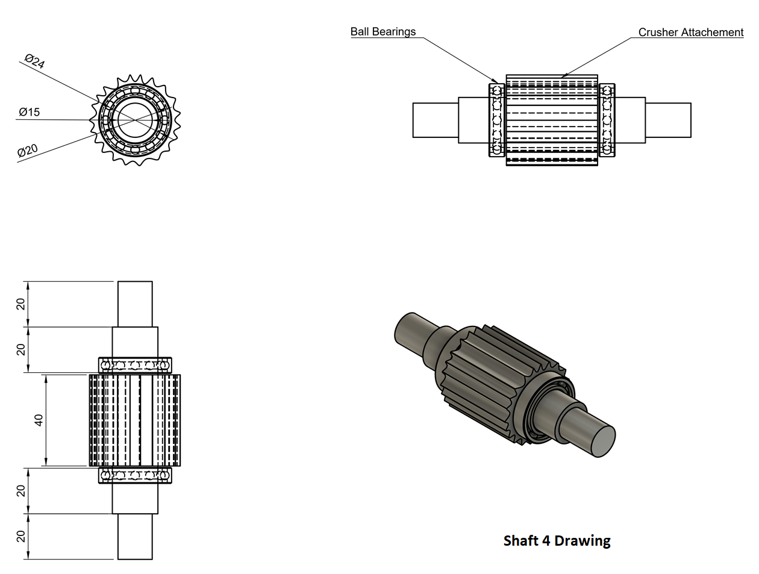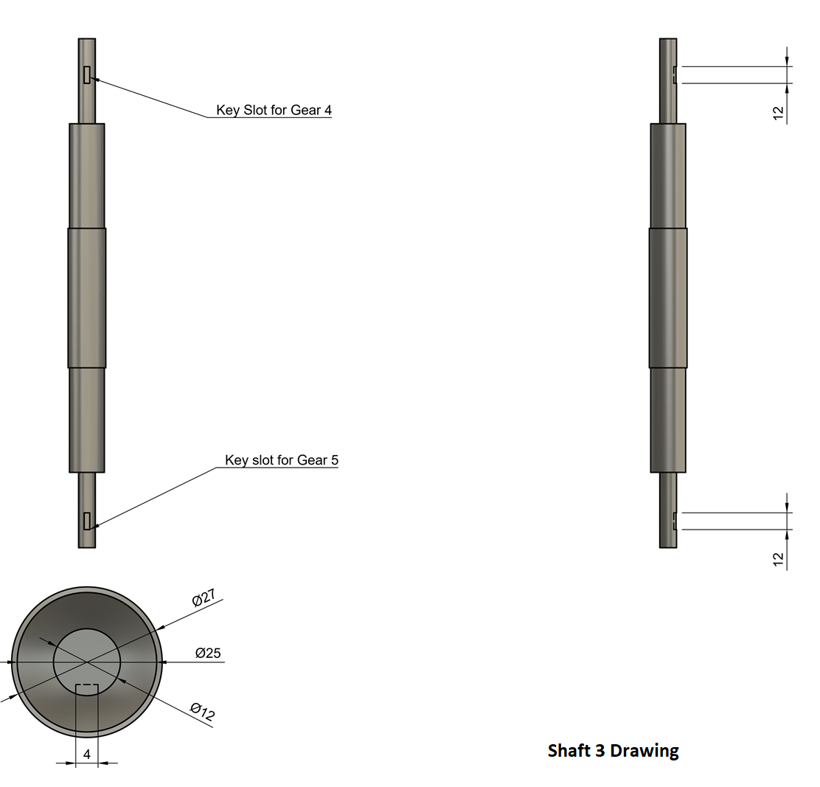

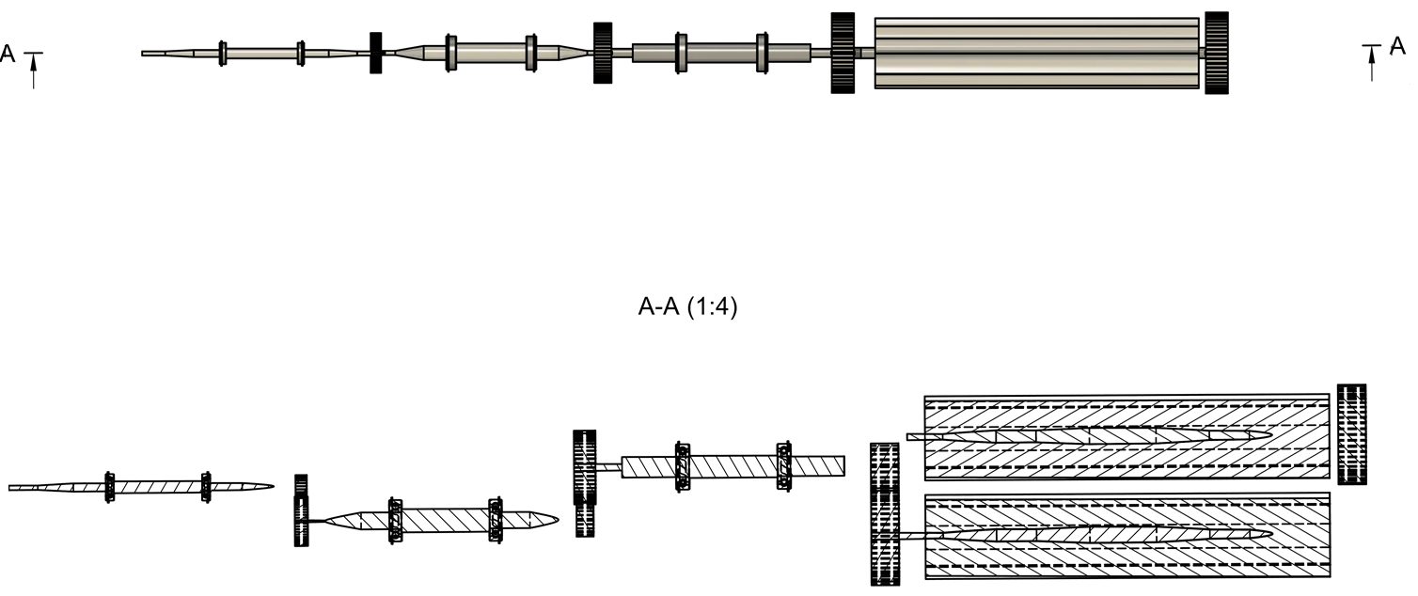

**Gear Train Drawing**